STEP 1

LOGIN with Respective Credentials

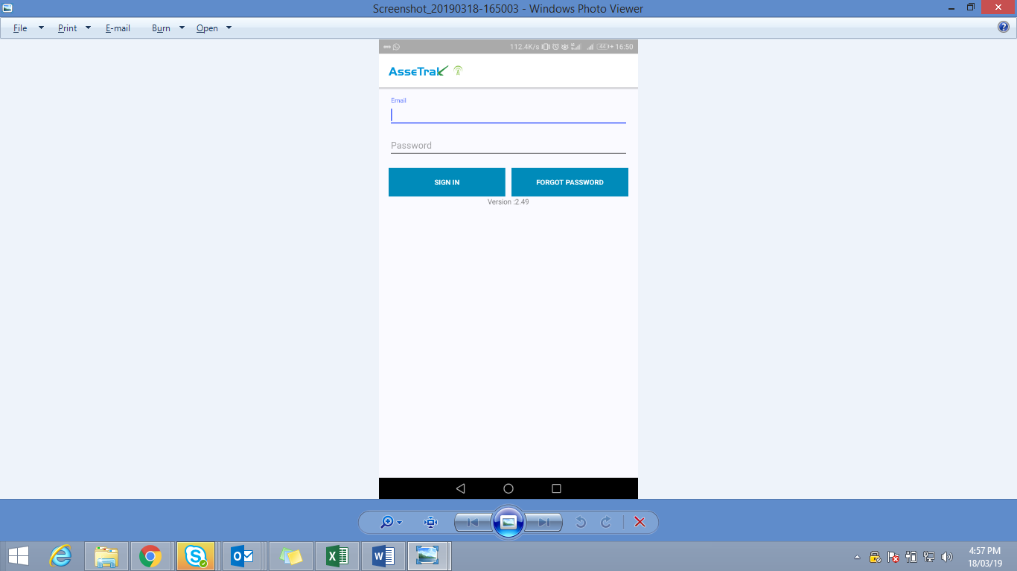

Step 2

**i SELECT COMPANY AS TATA**

**II SELECT PLANT**

**iii select PROJECT**

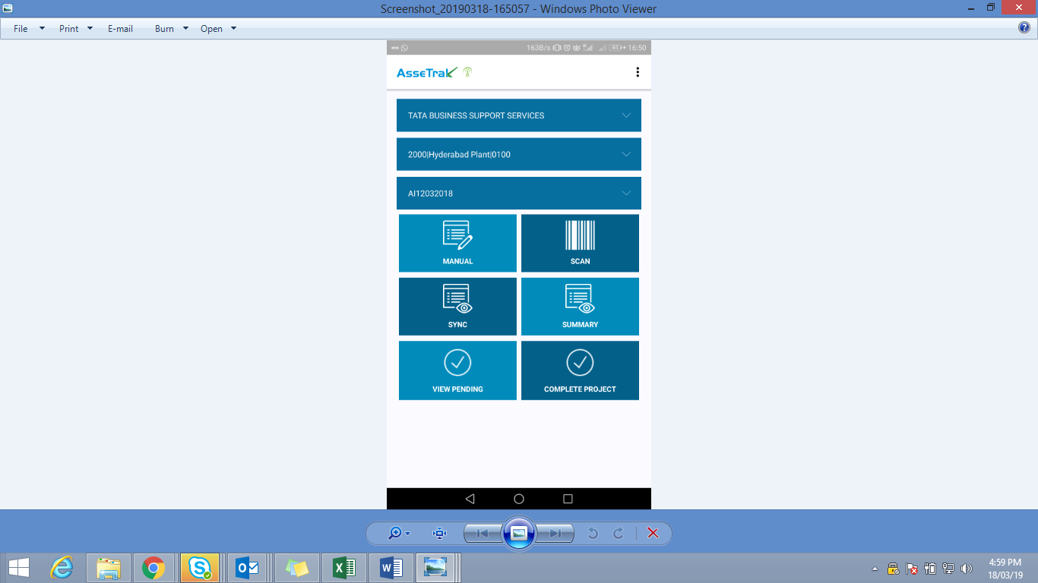

STEP 3

CLICK ON AUDIT

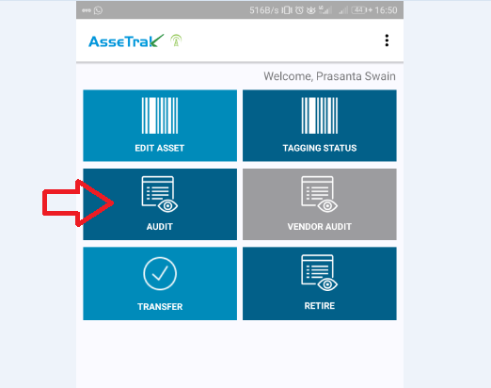

STEP 4

CLICK ON SCAN (POSITIVE)

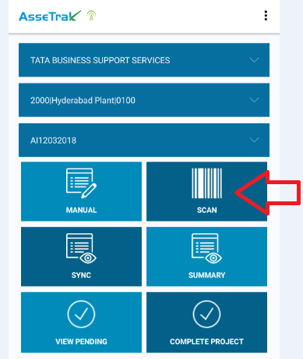

STEP 5

SYNC

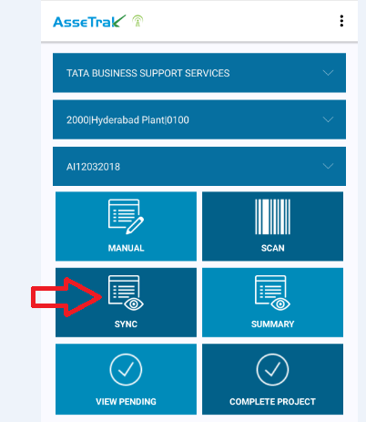

STEP 6

SUMMARY

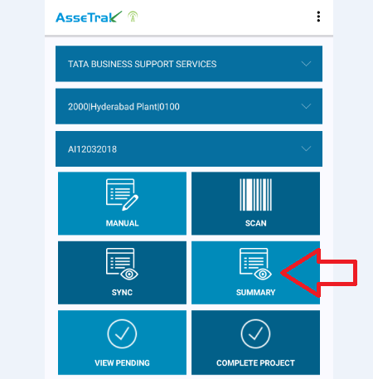

THIS WILL HELPYOU IN TOTAL COUNT COMPLTED.

****NOTE : DON’T CLICKI ON COMPLETE PROJECT *****